2013

By Shannon Gilley
rosegilleydesigns.com

Rose Gilley Designs
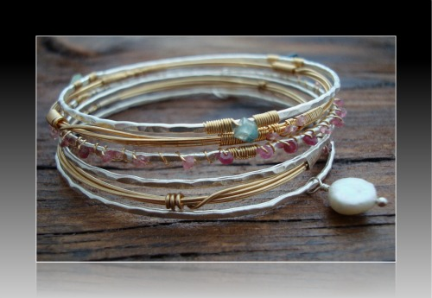

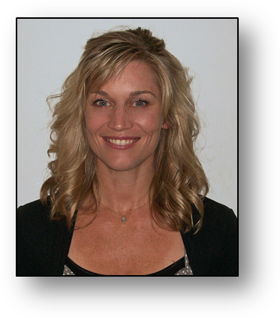
Jewelry designer and metalsmith Shannon Gilley scours the country searching for old Italian and Spanish coins, antique keys, brilliant gemstones and unique scrap metals to create her romantic jewelry line, Rose Gilley Designs. Shannon’s pieces have a distinctively textured yet whimsical look and feel, with semi-precious and precious stones and pearls wrapped in copper, silver and gold. She personally crafts each piece by hand from her studio in her hometown Sacramento, Calif. No two pieces are identical; only the original design is sold.
“You can take a flat piece of metal and you can turn it into anything you want—a rose or a hummingbird or a cuff,” she says. “How much fun is that?”
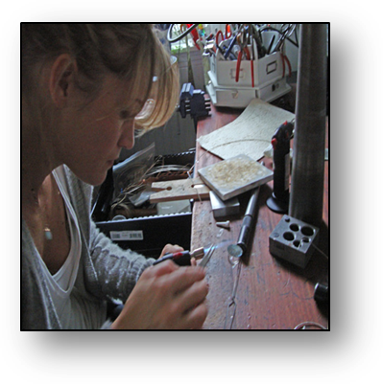
Jewelry is very personal to Shannon, as she views every piece not just as an accessory, but as an extension of a person’s personality. “My jewelry is like your favorite friend or relative; it’s comforting.”
Every aspect of Rose Gilley Designs is meaningful to Shannon. That’s why she partners with the Sexual Assault and Domestic Violence Center of Yolo County. Fifty percent of sales from one of her pieces, a specially created “A Rose is a Rose” sterling silver pendant, are dedicated to the center.
Rose (a family name and Shannon’s middle name) Gilley (Shannon’s maiden name) Designs are sold in 15 boutiques and hotels around the country and featured on fashion blogs and in local press.
To hear more from Shannon, check out the Frequently Asked Questions on page 4.
“Shannon has a simple, yet elegant style that appeals to all genres. She has impeccable attention to detail and uses only the highest quality materials.”
--Sandra Grignon, Spa Director, Bardessono Hotel in Napa Valley, CA

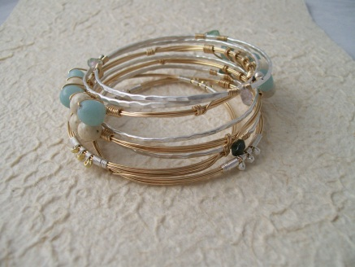
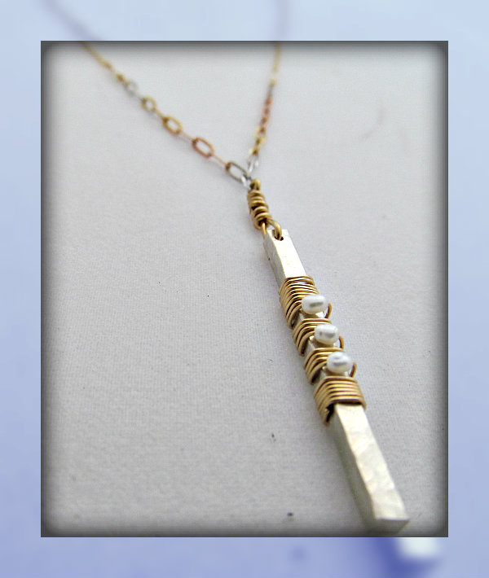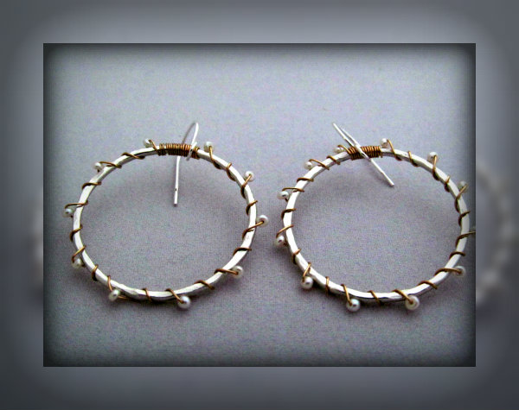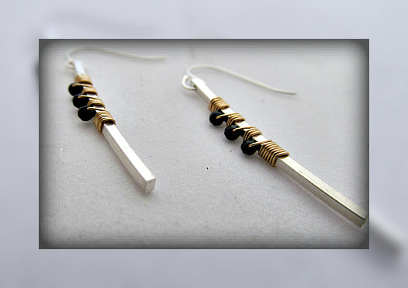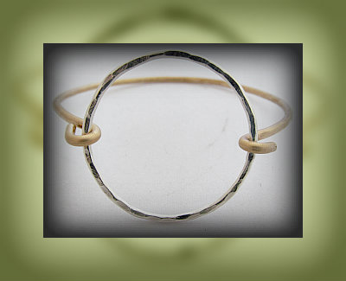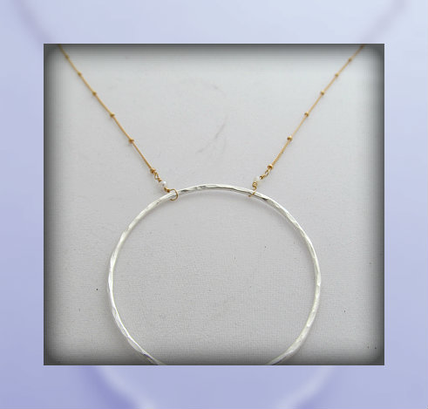

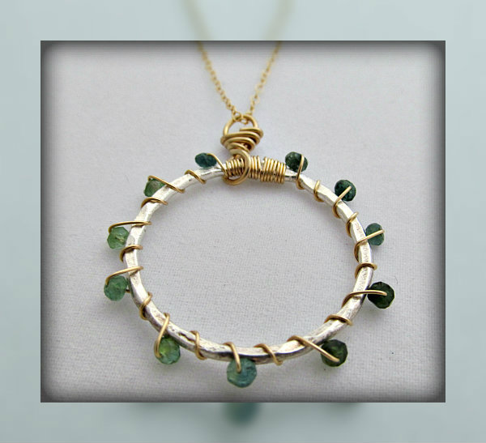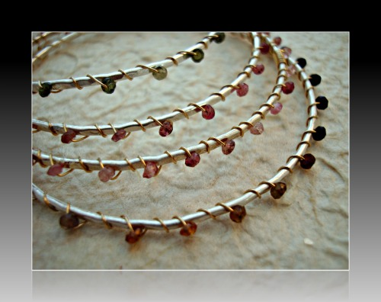
See the full collection at rosegilleydesigns.com
rosegilleydesigns@hotmail.com 916-204-6313

Rose Gilley Designs Featured:

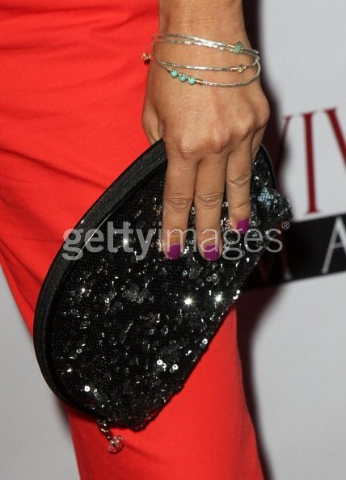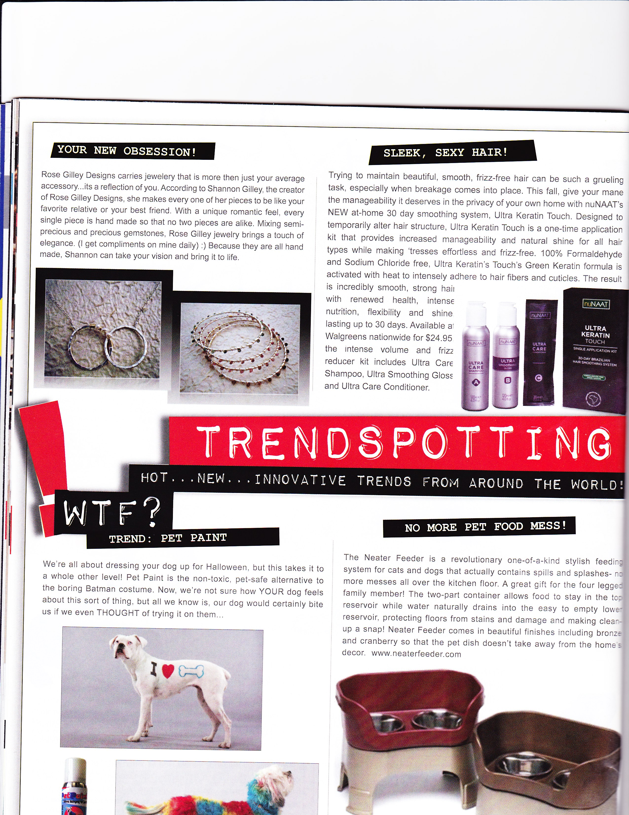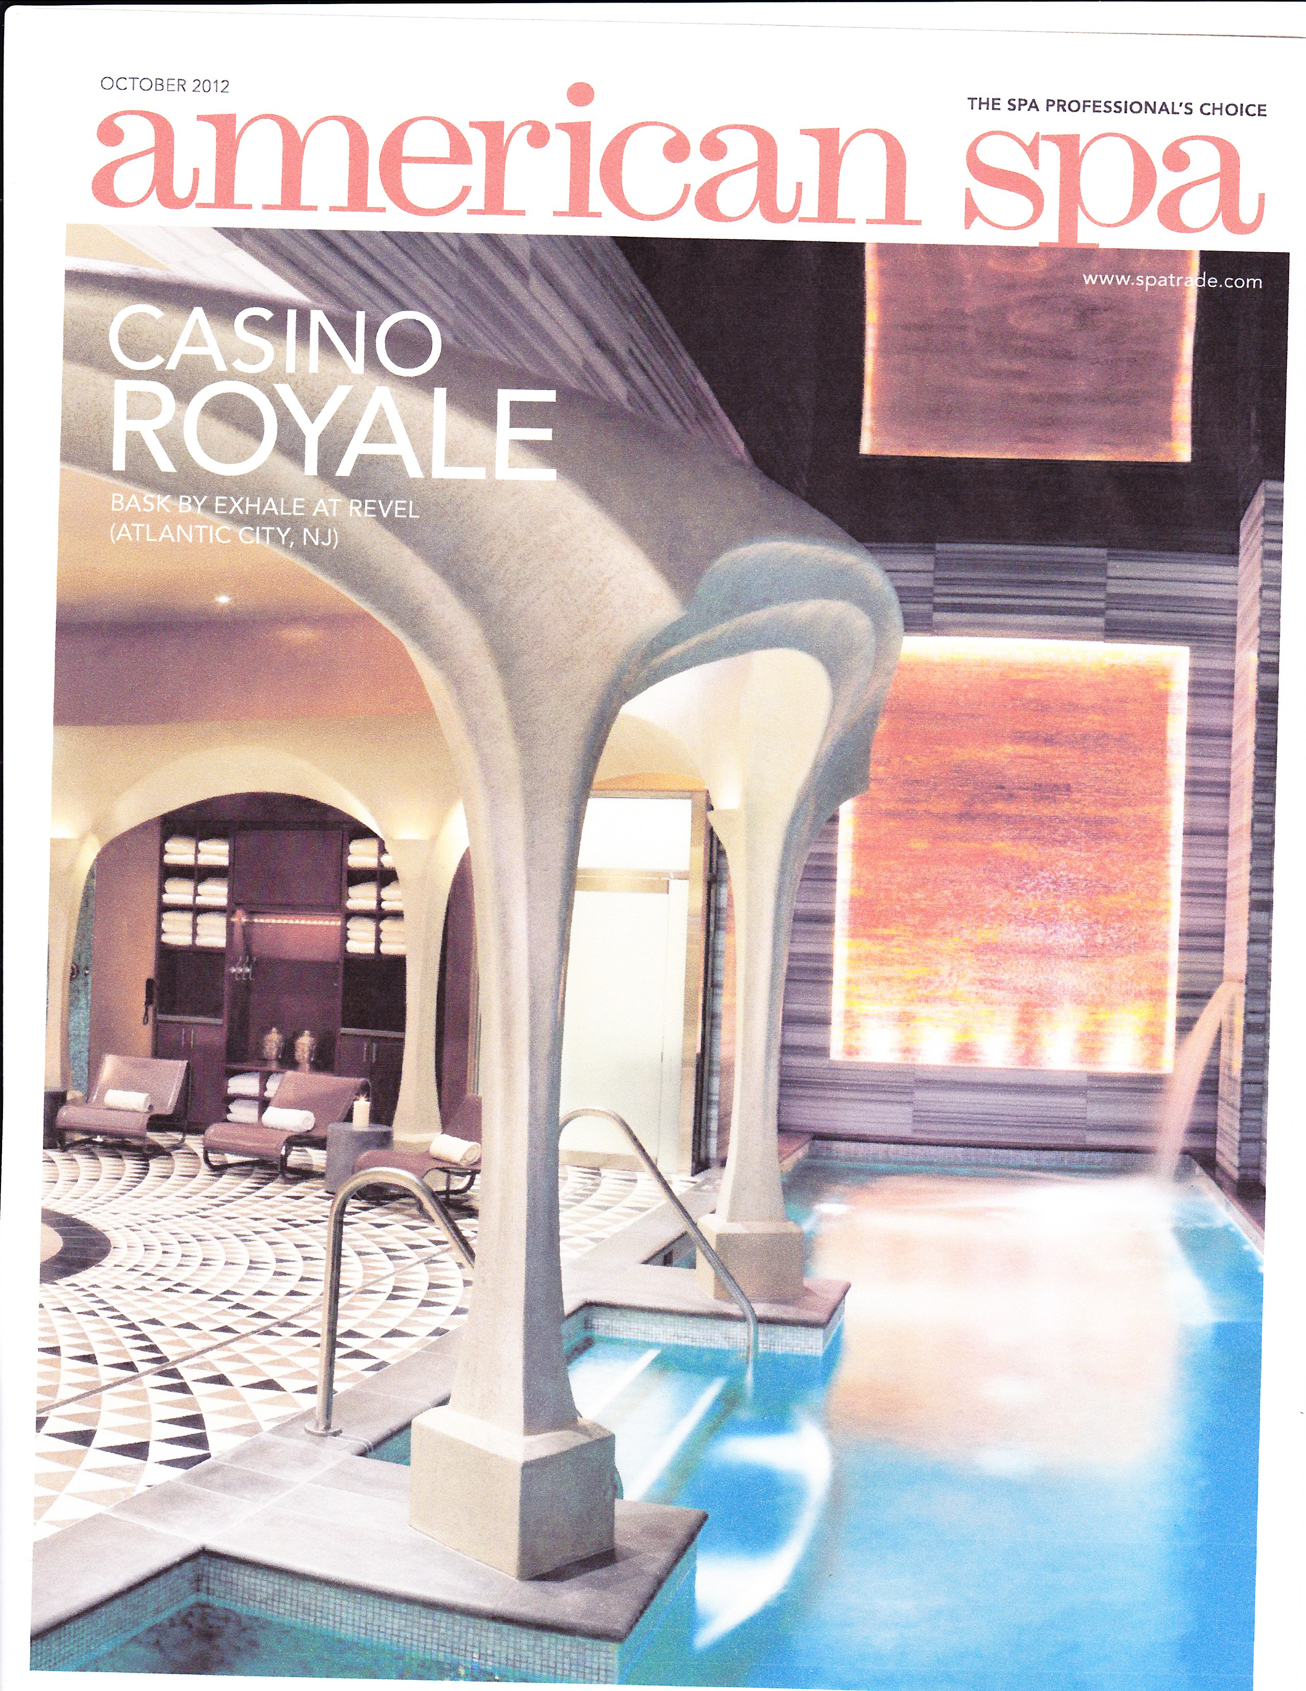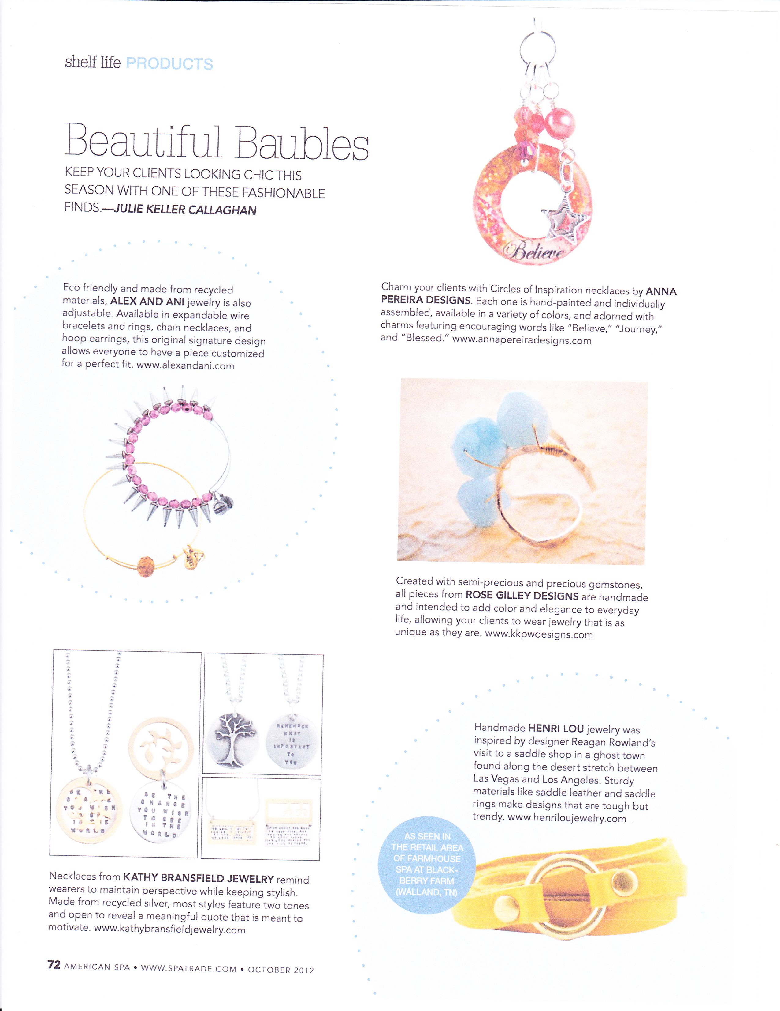
Online Features:
“Rose Gilley Designs are beautiful one-of-a-kind pieces: personal, powerful, inspirational and full of delight. To be collected, layered and worn daily. A breath of fresh air”.
--Pamela Tuohy-Novinsky, Owner & Designer, 2ETN
www.melindajoy.com
www.launchgrowjoy.com
www.thereviewbroads.com
www.mommyfactor.net
www.whomyouknow.com
www.beautyxpose.com
www.vivaglammagazine.com
www.champagneliving.net
www.essence.com – Essence Magazine Dec 2012 Holiday Guide

"I can't keep the bracelets in stock and people LOVE that it is all handmade by a local woman. They gravitate toward the light and airiness of it and that each piece is one of a kind."
--Mandy Michael, Manager, Serendipity Boutique in Sacramento, CA

Frequently Asked Questions:

What’s the meaning behind Rose Gilley?
Rose was my great grandmother’s name, my grandmother’s name and it’s my middle name, so it’s been a really special name in my family for generations. My company started as KKPW Designs (Knick Knack Patty Whack), but after losing my dad in 2010, I changed the company to include our family name Gilley, my maiden name. My jewelry now carries even more meaning and pride and reminds me of my dad, my biggest supporter, every day.
What’s your best seller?
My bangle bracelets are the most popular. One time, a woman even bought my bracelet right off my wrist! My stackable rings are popular too. People like that they can wear the individual pieces alone for a simpler look, or layer them for more of a statement. My rings and bangles have different colored gemstones, so people can mix and match to whatever they’re in the mood for that day.
Where does your inspiration come from?
My friends, family, the people that I meet, the places I go, the clothes I buy—it all inspires me. Often I find myself matching jewelry to someone’s personality or to an emotion. I like to think of my pieces as a friend, or even an extension of someone’s personality. They are comforting to wear. They reflect who you are and they make you feel special.
Where did you pick up your skills?
I am mostly self-taught. I took a metalsmith class years ago in San Francisco and I fell in love with it! I’m always experimenting with new techniques, tools and metals. When I’m working in my studio with my torch, I couldn’t be happier. I craft everything by hand, so no two pieces will ever be exactly the same. That’s part of what makes Rose Gilley Designs so special—since I work on every single piece, each one has so much meaning to me. My clients appreciate that .
What’s next for Rose Gilley?
Continuing to focus on pieces that keep my customers coming back time and time again. Creating the unique, one of a kind pieces, that many appreciate and hold on to for a long time. Better yet, is they pass them along.

